Spor Sepeti

System Design Document

v1.0

27.03.2019

Berkay Günay

Mert Pekdüzgün

Ögeday Sunar

Tuncer Oğuzkurt

Prepared for

SE302 Software Development Practice



Table of Contents

1. Introduction 1

1.1. Purpose of the System 1

1.2. Design Goals 1

• Security 1

• Reliability 1

• End User 1

• Performance 2

1.3. Definitions, Acronyms, and Abbreviations 2

1.4. References 2

2. Current Software Architecture 2

3. Proposed Software Architecture 3

3.1. Overview 3

3.2. System Decomposition 3

User Management Subsystem 3

Trainer Management Subsystem 4

Manager management subsystem 4

Sport Center Management Subsystem 4

Database subsystem 4

Storage subsystem 5

3.3. Hardware Software Mapping 5

3.4. Persistent Data Management 5

3.5. Access Control and Security 6

3.6. Global Software Control 8

3.7. Boundary Conditions 8

4. Subsystem Services 9

5. Mock-Ups 10

Main Screen 10

Sport Center Search Bar 11

Popular Sport Centers and Trainers in Main Screen 11

Side Bar 12

6. References 12

SYSTEM DESIGN DOCUMENT

# Introduction

The design is a work process which has a user perspective and drives development based on your specific customers’ needs. Methods and approaches differ depending on what you are developing. In the design part, it offers us both a guide to the customer and a guide to the development process for us. After the design part, we are able to reduce the time required the implementation.

## Purpose of the System

As stated in the Requirement Analysis Document, the aim of my sportsbook is to combine athletes and gyms and trainers to provide an easy and fast system for all users. The system allows users to join the gym or send a training program in a few clicks, and also offers many features such as adding a gym, deleting the gyms they add, and seeing each other.

## Design Goals

The design objectives indicate the specified characteristics of the sports cart system and provide a fixed set of standards that should be considered when making design selections. Based on non-functional requirements, the next design objectives need to be achieved as a way of qualifying the system profitably:

### Security

Information of users in the Firebase database, trainer or manager information, etc. We use it to save. Firebase is a Google company. When we make non-security settings, the Firebase warns us that Fir These settings are not secure Güvenlik. Firebase is a security platform for a web application. We have also set the rules of the database in Firebase settings; such users can write or read data in Firebase. We can determine such rules in Firebase.

### Reliability

We keep the user information in the database with the user's ID in the user's table. They can contact us if they think there is an error. Users can reach us if they think that there is a mistake when they enter the gyms. If the manager thinks that there is a mistake in building the gym, he can get to us. We'll give you feedback if it's done successfully.

### End User

If they are going to enter the website, all users can search the gym, vote, the managers can create a gym, the trainers can create their own profiles and enter the gyms. However, Anonymous Users can do nothing but see and search pages. When doing these, your phones, computers, or tablets must have an ethernet connection. Our application is for Web devices.

### Performance

Our system can be robust enough to manage any valid input from users. Our system can write and read data in the firebase database at the same time, it can support 100 users per second. The data exchange in our system is within 1-2 seconds.

In addition, the other objectives of the system that I design my design should accept upgrades and be applied to the website platform. Another thing is that we have to design our easy to understand and useful application. In addition, colors, images, and icons on our website must be linked together. Our display designs have HTML and CSS codes, and our functions have javascript codes. Our database is Firebase database. The user interface must be web-based.

## Definitions, Acronyms, and Abbreviations

**Visitor:** The system user who wants to search or view for all sports center.

**User:** The system user who wants to search view, join or create.

**Admin:** The system administrator who will manage all data system data and user controls.

**RAD:** Requirement Analysis Design

**SDD:** System Design Document

**Firebase:** Firebase is a Backend as a Service

**JS:** JavaScript

**HTML:** Hyper Text Markup Language

**CSS:** Cascading Style Sheets

## References

<https://www.sporcard.com/>

<https://www.sportsandmerits.com>

# Current Software Architecture

There is an existing system for web-based sports system. The system provides create a sports

center, view trainers program and joining the sports center or trainers program. Registered user can join any program or sports center but visitor user just views trainers program or sports

center. Some of the user types have created functions such as trainers or managers. All of the registered user’s type has a specific profile screen and they can view their information even view their programs or sports center status.

The problem that we consider is difficulties sports center and losses time. The new system

user’s register the web bases system and logins the system and they have a profile.An

an important case is users can join any sports center or trainer program easily. The new system is more safe and useful than the old system for the sports center. In our new system, user’s can join a sports center easily and save time because our system has all the information about the sports center or trainers.

# Proposed Software Architecture

The sporrsepeti system is a web-based online platform. This project will be useful users and

sports centers. Designed system is easy to use and reliable, has a user-friendly web interface.

In our system, the system allows users to view all sports centers, trainer information, trainer

programs or manager information.Also, users and all of the users can view all sport center

information. In addition, the system allows users to join a sports center, trainer program,

search trainer, create new sports center by the admin’s approval.

## Overview

During the system design, modeling of the web-based system is sporsepeti, we divided the designed system into subsystems. Our subsystems are admin management system, registered user management system, visitor user system, manager management system, trainer management system. These systems provide strong consistency and sustainability.

## System Decomposition

We have 5 subsystems in our system. Each one has a unique set of features and functionalities it provides to other subsystems. We achieved this by decomposing our domain model and using the object model. Then we filtered which were most crucial in achieving the tasks our system requires. Our subsystems are as follows:

* User management subsystem
* Trainer management subsystem
* Manager management subsystem
* Sport Center management subsytem
* Database subsystem

### User Management Subsystem

This subsystem manages user interactions with the system. It is responsible for allowing the user to Join Sport Center, Rate Sport Center, Search, Connect Trainer and View Training Program. It is also responsible for monitoring user login and logout. Services for this subsystem include:

* joinSportCenter()
* rateSportCenter()
* searchSportCenter()
* connectTrainer()
* viewTrainingProgram()
* authentication()

### Trainer Management Subsystem

This subsystem relates to trainer and user connection. It is responsible for creating a workout program for users. Services provided by this subsystem include:

* createWorkoutProgram()
* authentication()

### Manager management subsystem

This subsystem is managing manager accounts. It offers perform creating a sport center, deleting a sport center, aproving user request. Manager is the only actor who has permission to decision join to sport center as a user and join the sport center as a trainer. This subsystem uses managers operations.

* acceptUserRequest()
* rejectUserRequest()
* authentication()
* viewTrainers()
* createSportCenter()

### Sport Center Management Subsystem

This subsystem manages Sports Centers and theirs rating. It is also responsible for relation with user, trainer and admin. Services for this subsystem include:

* joinSportCenter()
* rateSportCenter()
* searchSportCenter()
* connectTrainer()
* viewSportCenter()
* authentication()
* viewOurTrainers()

### Database subsystem

This subsystem will be implemented by relational database management system which is Firebase. All subsystems are related and having service with this subsystem.

### Storage subsystem



## Hardware Software Mapping

Describe how subsystems are assigned to hardware and off-the-shelf components. It also lists the issues introduced by multiple nodes and software reuse.

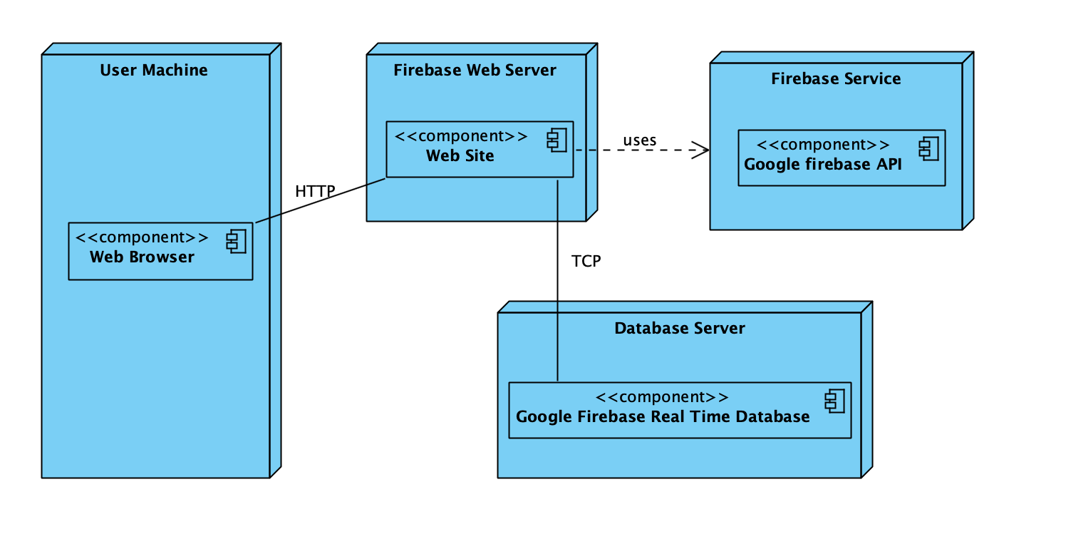

## Persistent Data Management

Our system will use the firebase system to store data. This system will facilitate and

faster to read and write data. The database user will store values ​​such as user input.

User, trainer, manager information and gyms information. Our database structure looks like this.



## Access Control and Security

The application is a multi-user application, so it consists of 5 types of users: the user, the visitor, the manager, the system administrator, and the trainer. Therefore, the application will provide different interfaces for each user type.

First of all, the system administrator will be connected to the system via the login interface and confirm or reject, delete and so on. As the administrator will perform the tasks in the appointment system. In the meantime, it is not necessary to register for the administrator through the system. On the website, the information will be entered manually in the database at the beginning of the system and will be the authority that will directly access the administrator database. In summary, the administrator is initially registered in the database and the system does not need to register.

The system registers all the information in the database and uses it to collect data from the system database for re-entry operations. The information in the database will use both the approval and the use of the system by the users.

The visitor must not log in to the system, search these gyms, view the pages and become a member. If the user wants to register or vote in gyms, they must be registered users to register in the system. The registered user must log in to update the profile, register with the gym, and contact the instructors.

After these steps, the registered user or trainer or sports center manager will be connected to the system with your information such as e-mail and password. During the login procedure, the data in the user database table will be obtained and compared with the data entered by the Registered User. Once logged in, the Registered User can add a gym, update his profile, contact the instructor, etc. During registration, no data access to the database is required, and data must be written to the database, which requires the data to be read and written to the database to complete the process. In this case, the required database fields will be blocked and the simultaneous access of multiple emails will be rejected.

For some situations, such as updating or deleting information, it is necessary to update one of the tables in the database at the completion stage and therefore several users (Registered Users, Visitor Users, Trainers, Gym Managers, and System Administrators) should be used with more caution. Updating the table at the same time. This will also be prevented by blocking.

Finally, viewing the information or lists again requires read-only access to the database. Therefore, multi-user access does not raise problems and new restrictions.

|  |  |  |  |
| --- | --- | --- | --- |
|  | SportCenter | authentication | Trainer |
| User | joinSportCenter()  viewSportCenter() | Login(), Logout() | viewTrainerProfile()  viewUserProfile()  contactwithUser()  contactwithTrainer()  createWorkoutProgram() |
| Trainer | viewSportCenters()  workOnSportCenters() | Login(), Logout() | editProfile()  viewProfile() |
| Manager | createSportCenter()  deleteSportCenter() | Login(), Logout() | rejectTrainerRequest()  acceptTrainerRequest() |
| Admin | acceptSportCenter()  rejectSportCenter() | Login(), Logout() | - |
| Visitor | ViewSportCenters() | SignUp() | viewTrainerProfile() |

## Global Software Control

External Control Flow (Between Subsystems): Sporsepeti system defined by the web

application and web server requests submission of user data. The system has multi-user and

all of the users can request at the same time. Control system defined as a single user control

flow. Users follow a form of a tree formed by links or defined buttons.

Concurrent Control: System is a web-based so all subsystems and components can run at the

same time for different user types (managers, trainers, users, admin or visitor users) in the web base application.

Internal Control (Within a Single Process): The system uses a database and database

response from the minimization steps. The system is based on the web pages structure so

design procedures more simply. Sporsepeti system has a control flow and calls the other

subsystems. Multiple processes can be required for a process by thread technology.

User Interface: User interface should be made through web pages. Web pages may have

many options and options depends on the user. These options and conditions

implemented on the web page. Some of the subsystems have different web pages.

Subsystems cannot be considered to have an event loop so events controlled by web pages.

## Boundary Conditions

Startup: go to the sporsepeti system URL and login system

Shut Down: click log out and after that close browser

**Error Conditions:**

**Logging in:**

o Username or password field can’t be blank.

o Username, the password is wrong or does not exist.

o Password and username don’t match.

o The password is not 8 characters long.

o The main page does not appear after login.

**User settings:**

o System occurs an error when the user update some information or

creating a new account.

o The user enters all necessary information but the system has an error so the user

request failure to perform.

**Data Entry:**

o The system views error message when entering wrong information.

o Some of the fields have necessary conditions like a password field.

**Manager Entry:**

o Manager information can’t exist.

o Manager information can’t be blank.

**Trainer Entry:**

o Trainer information can’t exist.

o Trainer information can’t be blank.

**Admin Entry:**

o Admin information can’t exist.

o Admin information can’t be blank.

**Trainer Program Entry:**

o Some of the information cannot be blank(Date trainer information).

o Date can’t be a date before today.

**Logging out:**

o System errors occur.

# Subsystem Services

The system design has many subsystems. These are Login Interface, Update Profile

Interface, User Interface, (managers, trainers, admins, users), Adding Sports Center, Create

Trainer Program. In our design is not bounded to the specific data source and components

and the sporsepeti system use control flow. Consequently, we can change the database source

or other necessary user changes or other source code updates.

In our web application, we follow MVC-based architecture so all of the code responsible and managing domain entities will be stored in Model classes. In addition, we use the MCV in our sporsepeti project.

**Login Interface:** Provides services to log in all of the users(Trainers, Managers, Users, Admins).

**Update Profile Interface:** Provides services for all of the registered user change their

information.

**User Interface:** Provides services for users for with other interfaces like login form or create a sports center.

**Adding Sports Center Interface:** Provides services for creating new sports center uses by

manager.

**Create Trainer Program Interface:** Provides services for creating new fitness program by

trainers.

**Data Access:** Contains all object and called the model of MCV.

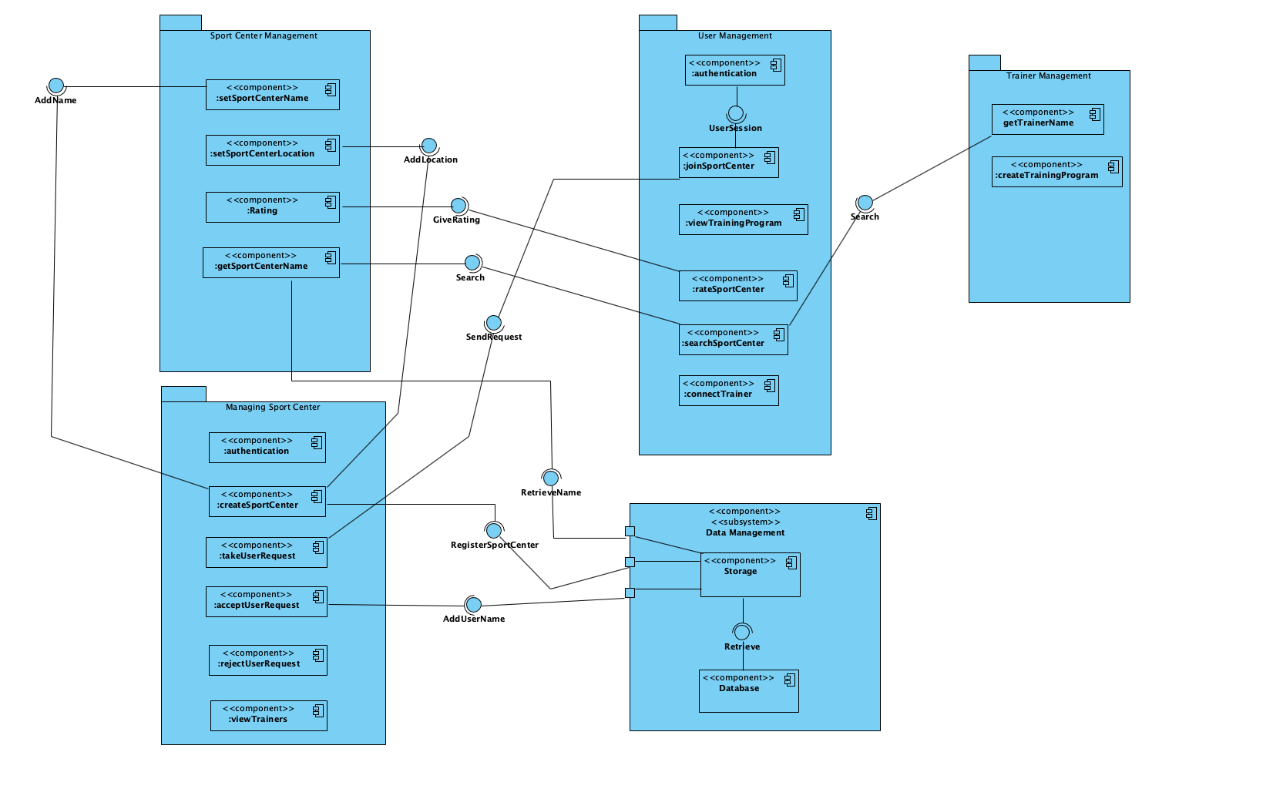

# Mock-Ups

### Main Screen

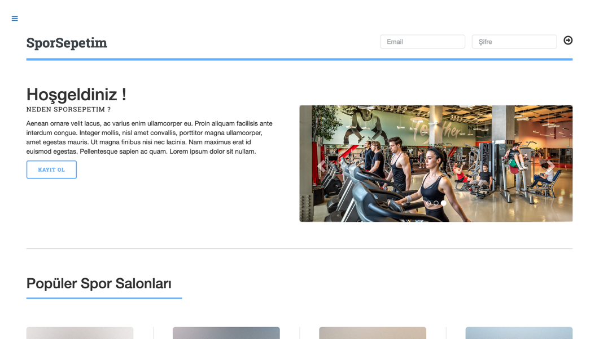

### Sport Center Search Bar

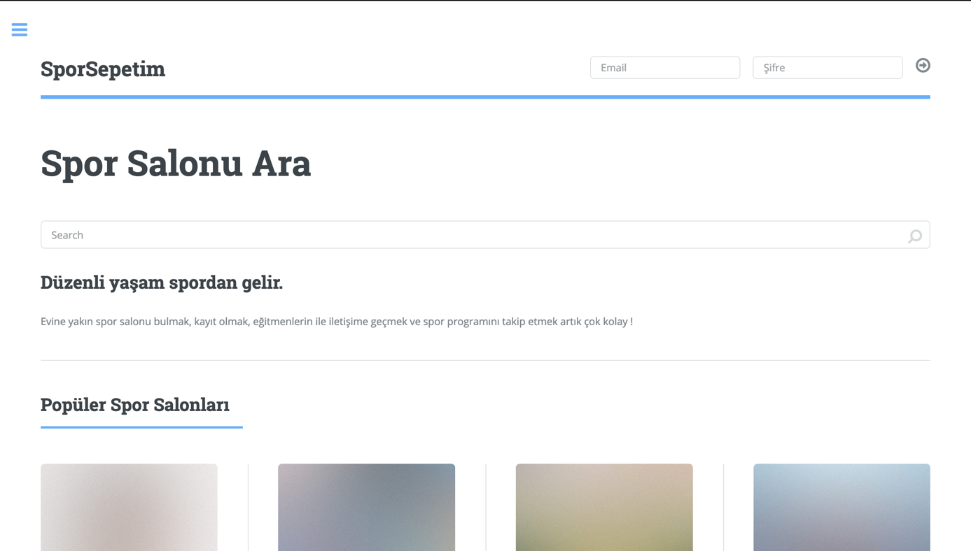

### Popular Sport Centers and Trainers in Main Screen

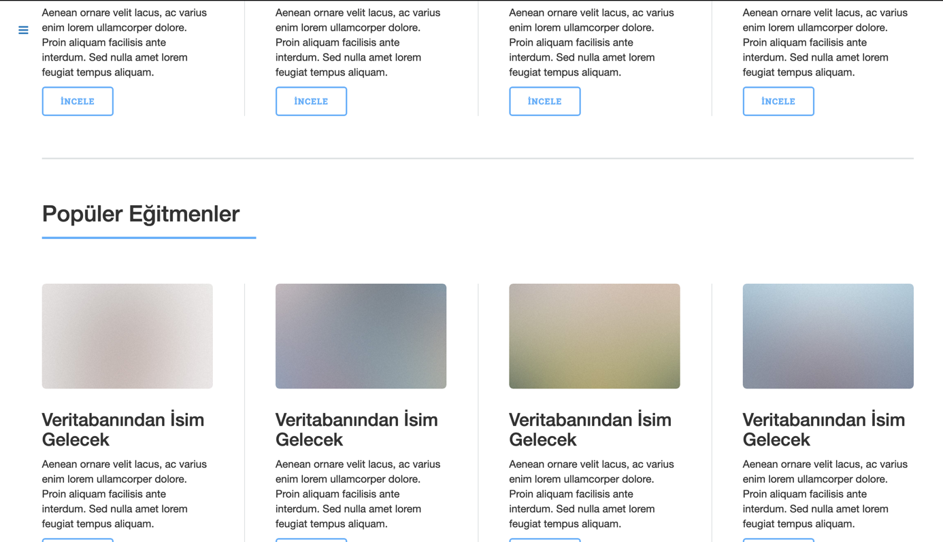

### Side Bar

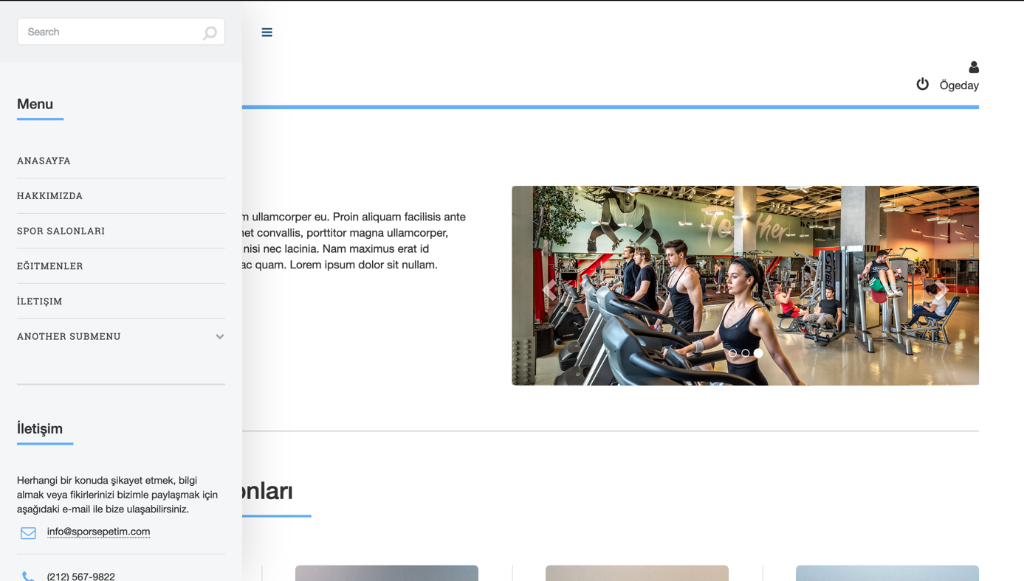

# References

1. Bruegge B. & Dutoit A.H.. (2010). *Object-Oriented Software Engineering Using UML, Patterns, and Java*, Prentice Hall, 3rd ed.
2. <http://www.tutorialsteacher.com/mvc/mvc-architecture>
3. <https://www.brainvire.com/six-benefits-of-using-mvc-model-for-effective-web-application-development/>
4. https://www.geeksforgeeks.org/mvc-design-pattern/
5. Enes Taylan, Huseyin Guler, Alperen Eraslan, Omer Durmus (2009). *Billiard Project, Object Oriented Software Engineering.*
6. Baekchun Kim, Jiwon Shin, Hailey Lee, Sung Woo Park, Sienna Schmid (2017). *Not Trash.*
7. Enes Taylan, Huseyin Guler, Alperen Eraslan, Omer Durmus (2009). *Billiard Project, Object Oriented Software Engineering.*
8. Baekchun Kim, Jiwon Shin, Hailey Lee, Sung Woo Park, Sienna Schmid (2017). *Not Trash.*